**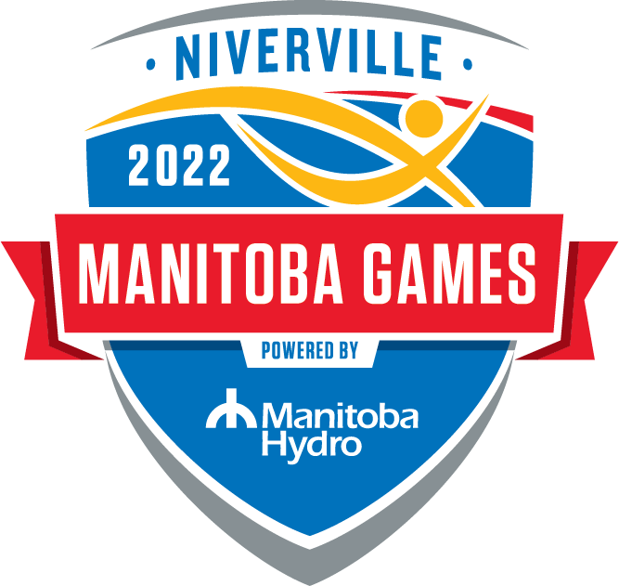**

**POWER SMART MANITOBA GAMES  
COACH / MANAGER APPLICATION FORM**

**CROSS COUNTY SKI**

The Cross Country Ski events will take place in Phase 1 of the Games with teams arriving in Niverville on Sunday February 27th and departing Wednesday March 2nd, 2022.

Two Coaches and one Manager will be selected for each regional team. At least one male and one female. At minimum, Coaches must be trained Community Coaches. All must undergo Volunteer Screening and be Respect in Sport certified.

More details in the [Technical Package](https://docs.google.com/document/d/18HWDDkWQiYephbJ8CxAEOwhfuJdAslTNzGvITcYN-sM/edit?usp=sharing).

1. Please indicate your preferred position:

Team Coach

Team Manager

1. Personal information:

Name:       Gender:

Address:         
 (Street, box number, town, postal code)

Mobile:       Email:

NCCP #

Respect in Sport certified?  Yes  Not yet

Do you have a child trying out for this team?  Yes  No

Are you currently coaching athletes in your club or region?  Yes  No

1. Coaching workshops completed to date or current certification status:

1. What coach training / workshops would you like to complete in 2021 – 2022?

1. Briefly describe your coaching experience to date:

1. Why are you seeking the above position with your regional Manitoba Games team?

By signing below you agree to follow the rules, regulations, policies and guidelines of Sport Manitoba, Manitoba Games, and the Cross Country Ski Association of Manitoba. You also agree to read, understand ad sign the CCSAM Coaches Code of Conduct.

Signature:       Date:

**APPLICATION DEADLINE: September 1, 2021**

Please submit applications to:

CCSAM_logo

145 Pacific Ave.

Winnipeg, MB R3B 2Z6

Email: [info@ccsam.ca](mailto:info@ccsam.ca)

Web: [www.ccsam.ca](http://www.ccsam.ca)

[www.games.ccsam.ca](http://www.manitobagames.ca)